**Nutrients**

The body requires many nutrients to carry out essential life processes.

There are 6 groups of nutrients:

1. Water – The fluid in which other substances are dissolved; chemical reactions in the cell occur in water and water molecules take part in some reactions.
2. Carbohydrates – Broken down into glucose; the main source of energy for cells.
3. Lipids – Broken down into fatty acids and glycerol; glycerol can enter the glycolysis pathway and be broken down to release energy in a similar way to glucose.
4. Proteins – Broken down into amino acids; amino acid molecules can be assembled into new proteins.
5. Minerals – May be part of enzymes; may function as co-factors for enzymes; may be part of substances e.g., ATP that are dissolved in metabolism.
6. Vitamins – Act as co-factors for many of the chemical reactions of metabolism.

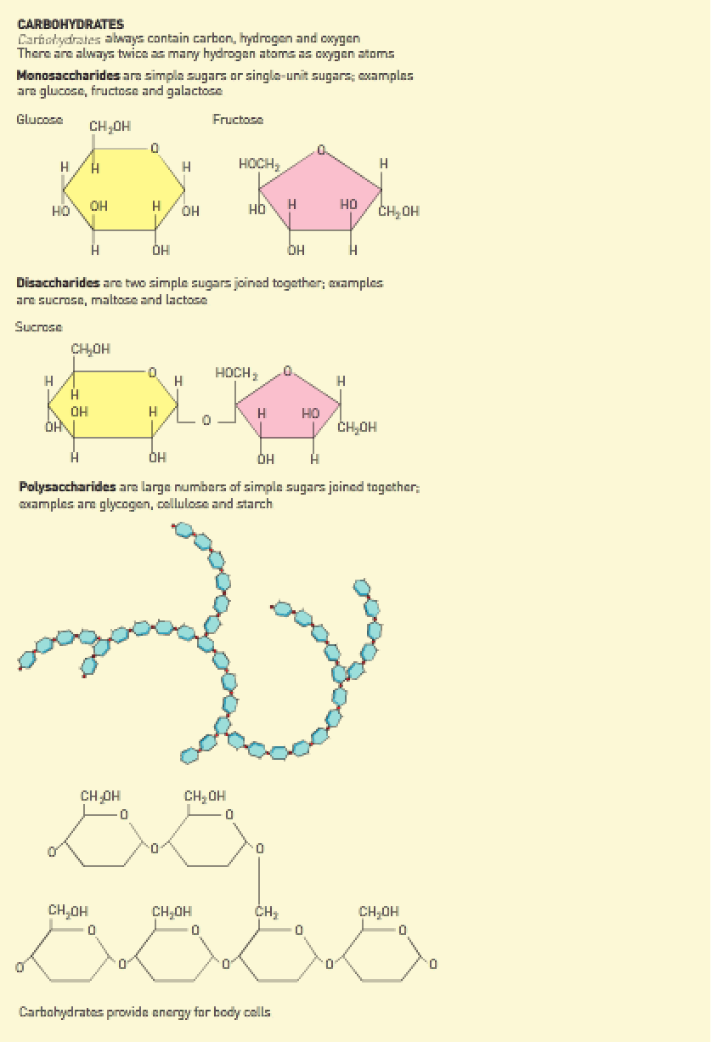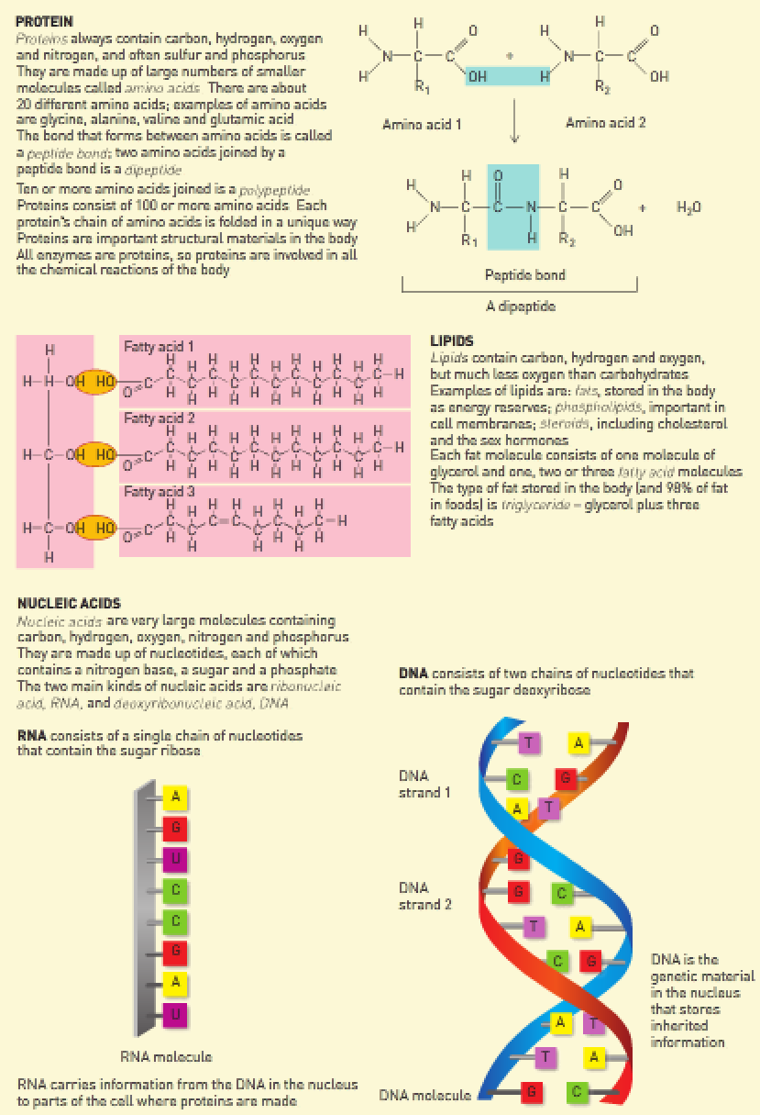

There are 2 types of nutrients:

1. Organic – Large molecules containing carbon.
2. Inorganic – Small molecules that don’t contain carbon.

Organic nutrients:

* Always contain the element carbon.
* Molecules containing carbon, hydrogen and oxygen (CHO).

Monosaccharides:

* Simple sugars or single-unit sugars.
* Always twice as many hydrogens as oxygens.
* Examples: Glucose, fructose and galactose.

Disaccharides:

* Complex sugars made up of 2 simple sugars.
* Examples: Sucrose, maltose and lactose.

Polysaccharides:

* Large molecules consisting of many simple sugars joined together.
* Examples: Glycogen (storage form of glucose), cellulose and starch.

Proteins:

* Molecules containing carbon, hydrogen, oxygen and nitrogen (CHON), often containing sulfur and phosphorus.
* The building blocks of proteins are amino acids.
* The bond that forms between amino acids is called a peptide bond.
* 2 amino acids joined together forms a dipeptide.
* 2 or more dipeptides joined together forms a peptide chain.
* 10 or more amino acids joined together forms a polypeptide.

Lipids:

* Molecules containing carbon, hydrogen and oxygen (CHO).
* Contains much less oxygen than carbon.
* Very dense store of energy in the body.
* Each fat molecule consists of one molecule of glycerol, 2 or 3 fatty acid molecules.
* Examples: Fats, phospholipids, steroids and sex hormones.

Nucleic acids:

* Molecules containing carbon, hydrogen, oxygen, nitrogen and phosphorus (CHONP).
* Made up of nucleotides.

There are 2 types:

1. Deoxyribose nucleic acids – Found in the nucleus as DNA.
2. Ribonucleic acids – Used by ribosomes for protein synthesis.

**Metabolism**

Metabolism: All the life-sustaining processes that occur in the body.

There are 2 types of metabolic reactions:

1. Catabolic reactions – Large molecules are broken down into smaller molecules.

* Energy is released.
* Example: Cellular respiration.

1. Anabolic reactions – Small molecules are built up into larger molecules.

* Example: Protein synthesis.

Most chemical processes in the body occur far too slowly to sustain life. The activation energy is very high.

Activation energy is the energy required for the reaction to proceed.

Special proteins called enzymes reduce the activation energy of reactions. Enzymes speed up chemical reactions.

Enzymes: Protein catalysts that speed up the rate of metabolic reactions.

Factors affecting enzyme activity:

1. Temperature – Optimal temperature is 37.7 degrees Celsius. Too high and the enzymes denature (burn and change shape). Too low and the enzymes slow down too much.
2. pH – Enzymes have specific pH’s that they function in.
3. Presence of co-factors/enzymes – Substances such as vitamins and minerals act to enhance enzyme activity. Enzymes become more efficient in their presence.
4. Amount of substrate – The more substrate, the more molecules that the enzymes can bind to and the more the enzyme activity. However, once all the substrate has been taken up, enzyme activity slows down.
5. Enzyme inhibitors – Some substances act to slow enzyme activity.
6. Concentration of enzymes – The higher the concentration, the faster the activity.
7. Product removal – At the end of the enzyme-substrate reaction, products are formed. The rate at which these products are removed influence enzyme activity. Generally, the higher the amount of product, the slower the removal of the product and the slower the enzyme activity.

**Cellular respiration**

Cellular respiration:

* The process by which organic molecules are broken down in the cells to release energy for the cell’s activities.
* Nutrients can all be broken down in cellular respiration to release energy.
* It’s a catabolic reaction that releases energy.

**6C6H12O6 + 6O2 → 6CO2 + 6H2O + energy**

Background information:

* Adenosine triphosphate is a high-energy molecule that’s required by cells to create energy for cell function.
* It has one Adenosine atom joined to 3 phosphate atoms.
* Food that’s ingested is broken down into glucose – glucose is used to create ATP.